**VISVESVARAYA TECHNOLOGICAL UNIVERSITY**

**“JnanaSangama”, Belgaum -590014, Karnataka.**



**LAB REPORT**

**On**

**DATA STRUCTURES (23CS3PCDST)**

**Submitted by**

**ABHAY NY (1BM24CS400)**

**in partial fulfillment for the award of the degree of**

**BACHELOR OF ENGINEERING**

**in**

**COMPUTER SCIENCE AND ENGINEERING**



**B.M.S. COLLEGE OF ENGINEERING**

**(Autonomous Institution under VTU)**

**BENGALURU-560019**

**September 2024-January 2025**

**B. M. S. College of Engineering,**

**Bull Temple Road, Bangalore 560019**

**(Affiliated To Visvesvaraya Technological University, Belgaum)**

**Department of Computer Science and Engineering**



This is to certify that the Lab work entitled **“DATA STRUCTURES”** carried out by ABHAY NY **(1BM24CS400 )**, who is bonafide student of **B. M. S. College of Engineering**. It is in partial fulfillment for the award of **Bachelor of Engineering in Computer Science and Engineering** of the Visvesvaraya Technological University, Belgaum during the year 2024-25. The Lab report has been approved as it satisfies the academic requirements in respect of Data structures Lab - **(23CS3PCDST)**work prescribed for the said degree.

**Prof. Sneha S Bagalkot** **Dr. Kavitha Sooda**

Assistant Professor Professor and Head

Department of CSE Department of CSE

BMSCE, Bengaluru BMSCE, Bengaluru

**Index Sheet**

|  |  |  |
| --- | --- | --- |
| **Sl.**  **No.** | **Experiment Title** | **Page No.** |
| 1. | Write a program to simulate the working of stack using an array with the following:  a) Push  b) Pop  c) Display  The program should print appropriate messages for stack overflow, stack underflow. | 6 – 12 |
| 2. | WAP to convert a given valid parenthesized infix arithmetic expression to postfix expression. The expression consists of single character operands and the binary operators + (plus), - (minus), * (multiply) and / (divide)  Program - Leetcode platform | 13 – 18 |
| 3. | 3a) WAP to simulate the working of a queue of integers using an array. Provide the following operations: Insert, Delete, Display  The program should print appropriate messages for queue empty and queue overflow conditions  3b ) WAP to simulate the working of a circular queue of integers using an array. Provide the following operations: Insert, Delete & Display  The program should print appropriate messages for queue empty and queue overflow conditions | 19 – 32 |
| 4. | WAP to Implement Singly Linked List with following operations  a) Create a linked list.  b) Insertion of a node at first position, at any position and at end of list.  Display the contents of the linked list.  Program - Leetcode platform | 33 – 41 |
| 5. | WAP to Implement Singly Linked List with following operations  a) Create a linked list.  b) Deletion of first element, specified element and last element in the list.  c) Display the contents of the linked list.  Program - Leetcode platform | 42 – 51 |
| 6. | 6a) WAP to Implement Single Link List with following operations: Sort the linked list, Reverse the linked list, Concatenation of two linked lists.  6b) WAP to Implement Single Link List to simulate Stack & Queue Operations. | 52 – 66 |
| 7. | WAP to Implement doubly link list with primitive operations  a) Create a doubly linked list.  b) Insert a new node to the left of the node.  c) Delete the node based on a specific value  d) Display the contents of the list  Program - Leetcode platform | 67 – 73 |
| 8. | Write a program  a) To construct a binary Search tree.  b) To traverse the tree using all the methods i.e., in-order,  preorder and post order  c) To display the elements in the tree.  Program - Leetcode platform | 74 – 79 |
| 9. | 9a) Write a program to traverse a graph using BFS method.  9b) Write a program to check whether given graph is connected or not using DFS method. | 80 – 85 |
| 10. | Given a File of N employee records with a set K of Keys(4-digit) which uniquely determine the records in file F.  Assume that file F is maintained in memory by a Hash Table (HT) of m memory locations with L as the set of memory addresses (2-digit) of locations in HT.  Let the keys in K and addresses in L are integers.  Design and develop a Program in C that uses Hash function H: K -> L as H(K)=K mod m (remainder method), and implement hashing technique to map a given key K to the address space L.  Resolve the collision (if any) using linear probing. | 86 – 88 |

**Course outcomes:**

|  |  |
| --- | --- |
| CO1 | Apply the concept of linear and nonlinear data structures. |
| CO2 | Analyze data structure operations for a given problem |
| CO3 | Design and develop solutions using the operations of linear and nonlinear data structure for a given specification. |
| CO4 | Conduct practical experiments for demonstrating the operations of different data structures. |

**Lab program 1:**

**Write a program to simulate the working of stack using an array with the following:**

**a) Push**

**b) Pop**

**c) Display**

**The program should print appropriate messages for stack overflow, stack underflow.**

#include <stdio.h>

#include <stdlib.h>

#define SIZE 3

int top = -1;

int stack[SIZE];

void push(int item) {

if (top == SIZE - 1) {

printf("\nStack overflow");

} else {

top++;

stack[top] = item;

printf("\nElement %d pushed to stack", item);

}

}

void pop() {

if (top == -1) {

printf("\nStack underflow");

} else {

printf("\nElement popped is %d", stack[top]);

top--;

}

}

void display() {

if (top == -1) {

printf("\nStack is empty");

} else {

printf("\nStack values:");

for (int i = top; i >= 0; i--) {

printf("\n%d", stack[i]);

}

}

}

int main() {

int ch, item;

for (;;) {

printf("\n\n1: Push");

printf("\n2: Pop");

printf("\n3: Display");

printf("\n4: Exit");

printf("\nEnter your choice: ");

scanf("%d", &ch);

switch (ch) {

case 1:

printf("Enter value to be pushed: ");

scanf("%d", &item);

push(item);

break;

case 2:

pop();

break;

case 3:

display();

break;

case 4:

exit(0);

break;

default:

printf("\nInvalid choice. Please try again.");

break;

}

}

return 0;

}

**Output :**

**Pushing values:**

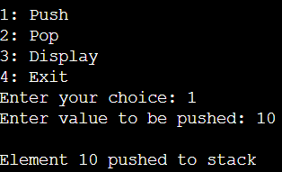

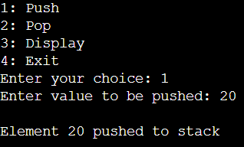

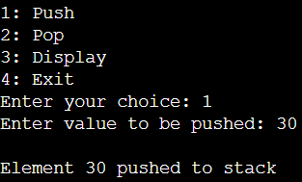

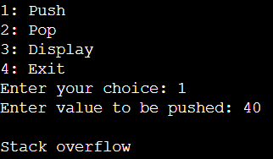

**Poping values:**

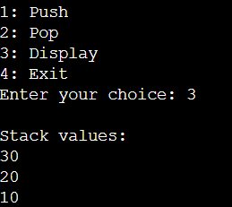

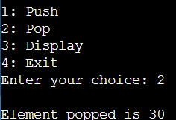

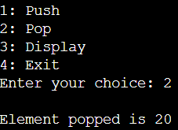

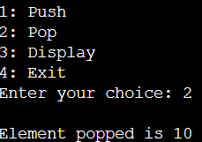

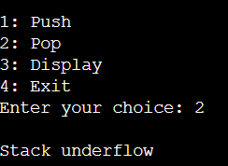

**Display:**

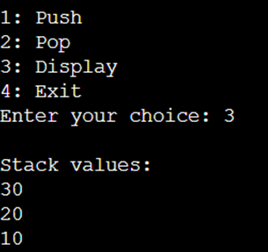

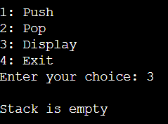

**Lab program 2:**

**Program to convert a given valid parenthesized infix arithmetic expression to postfix expression. The expression consists of single character operands and the binary operators + (plus), - (minus), * (multiply) and / (divide).**

**Code:**

#include <stdio.h>

#include <string.h>

#include <ctype.h>

#define SIZE 20

struct stack {

int top;

char data[SIZE];

};

typedef struct stack STACK;

void push(STACK *S, char item) {

if (S->top < SIZE - 1) {

S->data[++(S->top)] = item;

} else {

printf("Stack overflow!\n");

}

}

char pop(STACK *S) {

if (S->top != -1) {

return S->data[(S->top)--];

} else {

printf("Stack underflow!\n");

return '\0';

}

}

int preced(char symbol) {

switch (symbol) {

case '^': return 5;

case '*':

case '/': return 3;

case '+':

case '-': return 1;

default: return 0;

}

}

void infixpostfix(char infix[20], STACK *S) {

char postfix[20], symbol, temp;

int i, j = 0;

for (i = 0; infix[i] != '\0'; i++) {

symbol = infix[i];

if (isalnum(symbol)) {

postfix[j++] = symbol;

} else {

switch (symbol) {

case '(':

push(S, symbol);

break;

case ')':

while (S->top != -1 && (temp = pop(S)) != '(') {

postfix[j++] = temp;

}

break;

case '+':

case '-':

case '*':

case '/':

case '^':

while (S->top != -1 && preced(S->data[S->top]) >= preced(symbol)) {

postfix[j++] = pop(S);

}

push(S, symbol);

break;

}

}

}

while (S->top != -1) {

postfix[j++] = pop(S);

}

postfix[j] = '\0';

printf("\nPostfix expression is: %s\n", postfix);

}

int main() {

char infix[20];

STACK S;

S.top = -1;

printf("Enter infix expression: ");

scanf("%s", infix);

infixpostfix(infix, &S);

printf("\nName: Abhay NY \nUSN: 24BECS404\n");

return 0;

}

**Output:**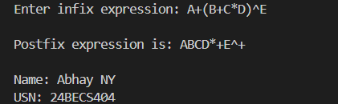

**Leet code:**

**3174. Clear Digits**

You are given a string s.

Your task is to remove all digits by doing this operation repeatedly:

Delete the first digit and the closest non-digit character to its left.

Return the resulting string after removing all digits.

Example 1:

Input: s = "abc"

Output: "abc"

Explanation:

There is no digit in the string.

Example 2:

Input: s = "cb34"

Output: ""

Explanation:

First, we apply the operation on s[2], and s becomes "c4".

Then we apply the operation on s[1], and s becomes "".

Constraints:

1 <= s.length <= 100

s consists only of lowercase English letters and digits.

The input is generated such that it is possible to delete all digits.

**Code:**

class Solution {

public:

    string clearDigits(string s) {

        int n = s.size();

        string ans = "";

        int i = 0;

        while(i < n)

        {

            if(isdigit(s[i]))

            {

                ans.pop_back();

            }

            else

            {

                ans.push_back(s[i]);

            }

            i++;

        }

        return ans;

    }

};

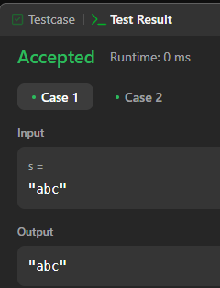

**Lab program 3:**

**a) WAP to simulate the working of a queue of integers using an array. Provide the following operations: Insert, Delete, Display**

**The program should print appropriate messages for queue empty and queue overflow conditions**

**Code:**

#include <stdio.h>

#include <stdlib.h>

#define SIZE 5

int front = -1 , rear = -1 ;

int q[SIZE];

void enqueue (int item)

{

if(rear==SIZE-1)

printf("\n Queue is full ");

else{

rear=rear+1;

q[rear]=item;

if(front==-1)

front=front+1;

}

}

void dequeue()

{

int del;

if(front==-1)

printf("\n Queue is empty");

else{

del=q[front];

printf("\n Element deleted is : %d",del);

if(front==rear)

{

front=-1;rear=-1;

}

else{

front=front+1;

}

}

}

void display()

{

int i;

if(front==-1)

printf("\n Queue is empty");

else{

printf("\n Queue content \n");

for (i=front;i<=rear;i++)

printf("%d\t",q[i]);

}

}

int main()

{

int item,ch;

for(;;)

{

printf("\n 1. Insert");

printf("\n 2. Delete");

printf("\n 3. Display");

printf("\n 4. Exit");

printf("\n read choice ");

scanf("%d",&ch);

switch(ch)

{

case 1 : printf("\n Read element to be inserted ");

scanf("%d", & item);

enqueue(item);

break;

case 2 : dequeue();

break;

case 3 : display();

break;

default : exit (0);

}

}

return 0;

**Output:**

**Enqueue and Display**

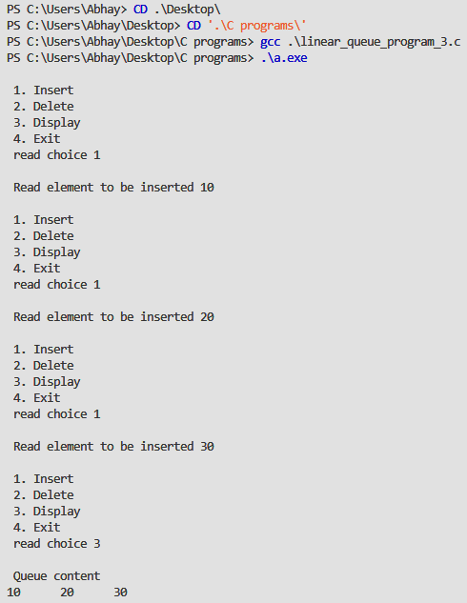

**Queue is full**

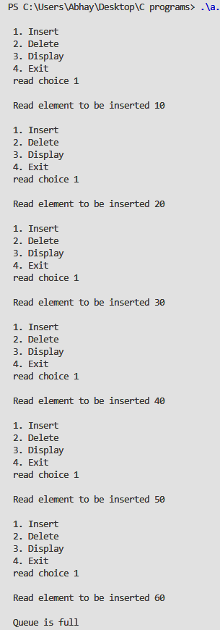

**Deletion and printing the queue is empty**

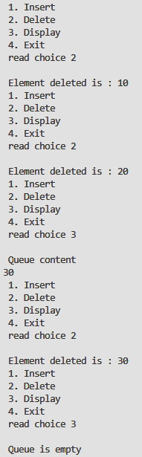

**Exit Command**

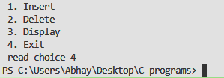

**b) WAP to simulate the working of a circular queue of integers using an array. Provide the following operations: Insert, Delete & Display**

**The program should print appropriate messages for queue empty and queue overflow conditions**

#include <stdio.h>

#include <stdlib.h>

#define size 5

int f=-1;

int r=-1;

int q[size];

void enqueue(int item)

{

    if(f==(r+1)%size)

    printf("Queue is full");

    else{

        r=(r+1)%size;

        q[r]=item;

        if(f==-1)

            f=f+1;

    }

}

void dequeue()

{

    if(f==-1)

    printf("Queue is empty");

    else{

        printf("\n Elements deleted is %d ",q[f]);

        if(f==r)

        {

            f=-1;

            r=-1;

        }

        else{

            f=(f+1)%size;

        }

    }

}

void display()

{

    int i;

    if(f==-1)

        printf("Queue is empty");

    else{

        printf("\n Content of queue : \n");

        for(i=f ; i!=r ; i=(i+1)%size)

        printf("%d \t",q[i]);

        printf("%d \t", q[r]);

    }

}

int main()

{

    int ch , item;

    for(;;)

    {

        printf("\n 1. Insert");

        printf("\n 2. Delete");

        printf("\n 3. Display");

        printf("\n 4. Exit");

        printf("\n Read choice : ");

        scanf("%d",&ch);

        switch(ch)

        {

            case 1 : printf("\n Enter element to be inserted : ");

                    scanf("%d",&item);

                    enqueue(item);

                    break;

            case 2 : dequeue();

                    break;

            case 3 : display();

                    break;

            default : exit(0);

        }

    }return 0;}

**Enqueue into the circular queue and displaying**

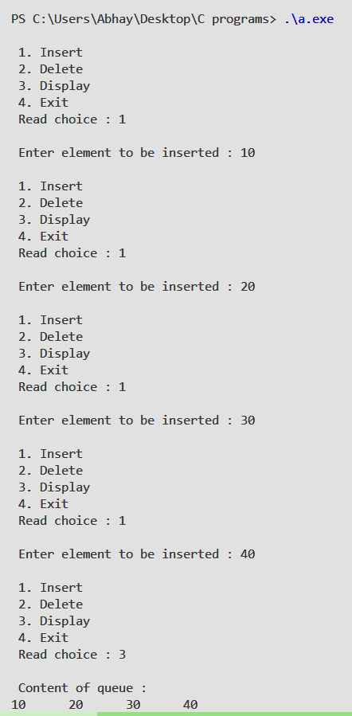

**Circular queue overflow**

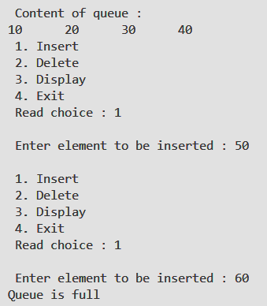

**Deleting elements form the queue till queue is empty**

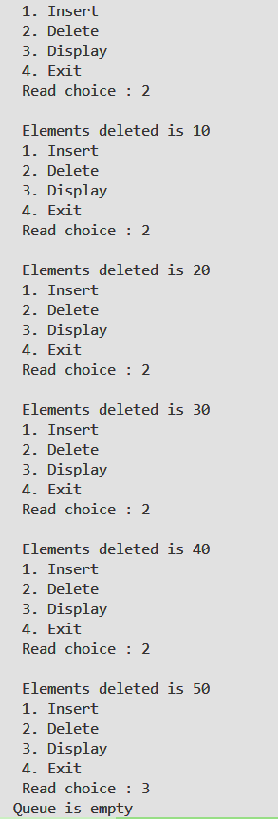

**Checking the Circular list working**

**First we enter 3 elements and then delete once and enqueue 40 to the queue .**

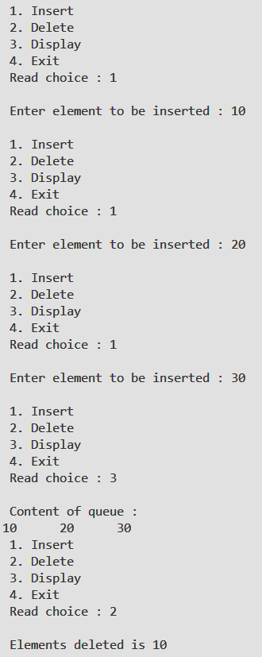

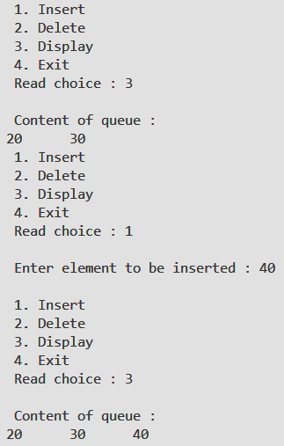

**Lab program 4:**

**WAP to Implement Singly Linked List with following operations**

**a) Create a linked list.**

**b) Insertion of a node at first position, at any position and at end of list.**

**Display the contents of the linked list.**

#include <stdio.h>

#include <stdlib.h>

struct Node {

int data;

struct Node* next;

};

void createLinkedList(struct Node** head);

void insertAtBeginning(struct Node** head, int data);

void insertAtPosition(struct Node** head, int data, int position);

void insertAtEnd(struct Node** head, int data);

void displayList(struct Node* head);

int main() {

struct Node* head = NULL; // Initialize the linked list as empty

int choice, data, position;

while (1) {

printf("\nMenu:\n");

printf("1. Create Linked List\n");

printf("2. Insert at Beginning\n");

printf("3. Insert at Position\n");

printf("4. Insert at End\n");

printf("5. Display List\n");

printf("6. Exit\n");

printf("Enter your choice: ");

scanf("%d", &choice);

switch (choice) {

case 1:

createLinkedList(&head);

break;

case 2:

printf("Enter data to insert: ");

scanf("%d", &data);

insertAtBeginning(&head, data);

break;

case 3:

printf("Enter data to insert: ");

scanf("%d", &data);

printf("Enter position: ");

scanf("%d", &position);

insertAtPosition(&head, data, position);

break;

case 4:

printf("Enter data to insert: ");

scanf("%d", &data);

insertAtEnd(&head, data);

break;

case 5:

displayList(head);

break;

case 6:

printf("Exiting...\n");

exit(0);

default:

printf("Invalid choice! Please try again.\n");

}

}

return 0;

}

void createLinkedList(struct Node** head) {

int n, data;

printf("Enter the number of nodes: ");

scanf("%d", &n);

for (int i = 0; i < n; i++) {

printf("Enter data for node %d: ", i + 1);

scanf("%d", &data);

insertAtEnd(head, data);

}

}

void insertAtBeginning(struct Node** head, int data) {

struct Node* newNode = (struct Node*)malloc(sizeof(struct Node));

if (!newNode) {

printf("Memory allocation failed!\n");

return;

}

newNode->data = data;

newNode->next = *head;

*head = newNode;

}

void insertAtPosition(struct Node** head, int data, int position) {

struct Node* newNode = (struct Node*)malloc(sizeof(struct Node));

if (!newNode) {

printf("Memory allocation failed!\n");

return;

}

newNode->data = data;

if (position == 1) {

newNode->next = *head;

*head = newNode;

return;

}

struct Node* temp = *head;

for (int i = 1; i < position - 1 && temp != NULL; i++) {

temp = temp->next;

}

if (temp == NULL) {

printf("Position out of bounds!\n");

free(newNode);

return;

}

newNode->next = temp->next;

temp->next = newNode;

}

void insertAtEnd(struct Node** head, int data) {

struct Node* newNode = (struct Node*)malloc(sizeof(struct Node));

if (!newNode) {

printf("Memory allocation failed!\n");

return;

}

newNode->data = data;

newNode->next = NULL;

if (*head == NULL) {

*head = newNode;

return;

}

struct Node* temp = *head;

while (temp->next != NULL) {

temp = temp->next;

}

temp->next = newNode;

}

void displayList(struct Node* head) {

if (head == NULL) {

printf("The list is empty!\n");

return;

}

struct Node* temp = head;

printf("Linked List: ");

while (temp != NULL) {

printf("%d -> ", temp->data);

temp = temp->next;

}

printf("NULL\n");

}

**Output:**

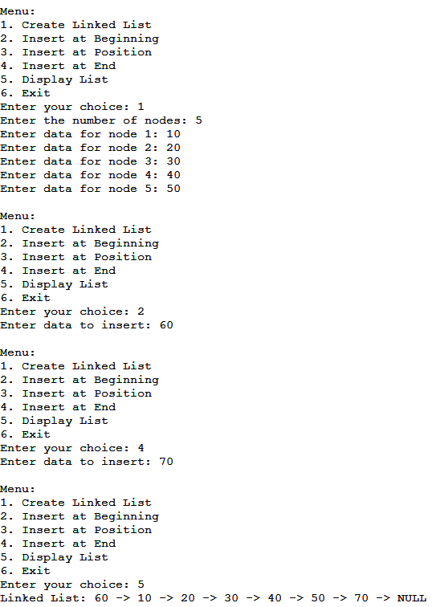

**Leet code Questions**

**2073. Time needed to buy tickets**

There are n people in a line queuing to buy tickets, where the 0th person is at the front of the line and the (n - 1)th person is at the back of the line.

You are given a 0-indexed integer array tickets of length n where the number of tickets that the ith person would like to buy is tickets[i].

Each person takes exactly 1 second to buy a ticket. A person can only buy 1 ticket at a time and has to go back to the end of the line (which happens instantaneously) in order to buy more tickets. If a person does not have any tickets left to buy, the person will leave the line.

Return the time taken for the person initially at position k (0-indexed) to finish buying tickets.

class Solution {

public:

    int timeRequiredToBuy(vector<int>& tickets, int k) {

        int n = tickets.size();

        int time = 0;

        // If person k only needs one ticket, return the time to buy it

        if (tickets[k] == 1)

            return k + 1;

        // Continue buying tickets until person k buys all their tickets

        while (tickets[k] > 0) {

            for (int i = 0; i < n; i++) {

                // Buy a ticket at index 'i' if available

                if (tickets[i] != 0) {

                    tickets[i]--;

                    time++;

                }

                // If person k bought all their tickets, return the time

                if (tickets[k] == 0)

                    return time;

            }

        }

        return time;

    }

};

Output:

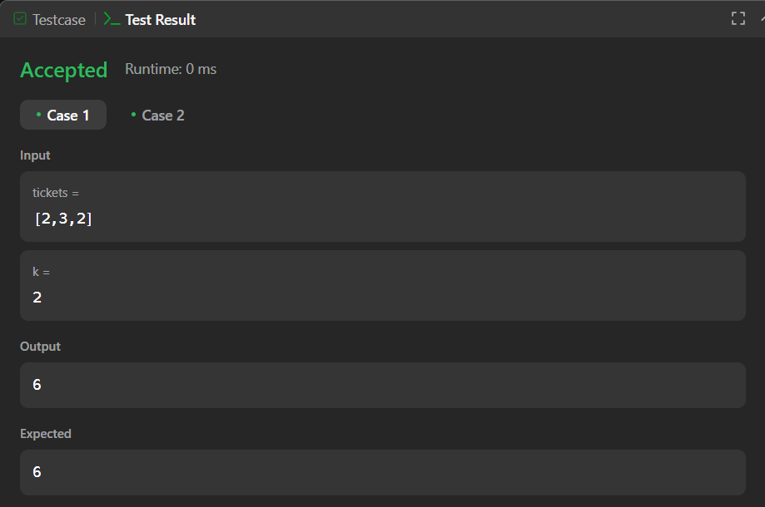

**Lab program 5:**

**WAP to Implement Singly Linked List with following operations**

**a) Create a linked list.**

**b) Deletion of first element, specified element and last element in the list.**

**c) Display the contents of the linked list.**

**Code:**

#include <stdio.h>

#include <stdlib.h>

struct Node {

int data;

struct Node* next;

};

void createLinkedList(struct Node** head);

void deleteFirst(struct Node** head);

void deleteSpecified(struct Node** head, int key);

void deleteLast(struct Node** head);

void displayList(struct Node* head);

int main() {

struct Node* head = NULL; // Initialize the linked list as empty

int choice, data;

while (1) {

printf("\nMenu:\n");

printf("1. Create Linked List\n");

printf("2. Delete First Element\n");

printf("3. Delete Specified Element\n");

printf("4. Delete Last Element\n");

printf("5. Display List\n");

printf("6. Exit\n");

printf("Enter your choice: ");

scanf("%d", &choice);

switch (choice) {

case 1:

createLinkedList(&head);

break;

case 2:

deleteFirst(&head);

break;

case 3:

printf("Enter the element to delete: ");

scanf("%d", &data);

deleteSpecified(&head, data);

break;

case 4:

deleteLast(&head);

break;

case 5:

displayList(head);

break;

case 6:

printf("Exiting...\n");

exit(0);

default:

printf("Invalid choice! Please try again.\n");

}

}

return 0;

}

void createLinkedList(struct Node** head) {

int n, data;

printf("Enter the number of nodes: ");

scanf("%d", &n);

for (int i = 0; i < n; i++) {

printf("Enter data for node %d: ", i + 1);

scanf("%d", &data);

struct Node* newNode = (struct Node*)malloc(sizeof(struct Node));

if (!newNode) {

printf("Memory allocation failed!\n");

return;

}

newNode->data = data;

newNode->next = NULL;

if (*head == NULL) {

*head = newNode;

} else {

struct Node* temp = *head;

while (temp->next != NULL) {

temp = temp->next;

}

temp->next = newNode;

}

}

}

void deleteFirst(struct Node** head) {

if (*head == NULL) {

printf("The list is empty!\n");

return;

}

struct Node* temp = *head;

*head = (*head)->next;

free(temp);

printf("First element deleted.\n");

}

void deleteSpecified(struct Node** head, int key) {

if (*head == NULL) {

printf("The list is empty!\n");

return;

}

struct Node* temp = *head;

struct Node* prev = NULL;

if (temp != NULL && temp->data == key) {

*head = temp->next;

free(temp);

printf("Element %d deleted.\n", key);

return;

}

while (temp != NULL && temp->data != key) {

prev = temp;

temp = temp->next;

}

if (temp == NULL) {

printf("Element %d not found in the list!\n", key);

return;

}

prev->next = temp->next;

free(temp);

printf("Element %d deleted.\n", key);

}

void deleteLast(struct Node** head) {

if (*head == NULL) {

printf("The list is empty!\n");

return;

}

struct Node* temp = *head;

struct Node* prev = NULL;

if (temp->next == NULL) {

*head = NULL;

free(temp);

printf("Last element deleted.\n");

return;

}

while (temp->next != NULL) {

prev = temp;

temp = temp->next;

}

prev->next = NULL;

free(temp);

printf("Last element deleted.\n");

}

void displayList(struct Node* head) {

if (head == NULL) {

printf("The list is empty!\n");

return;

}

struct Node* temp = head;

printf("Linked List: ");

while (temp != NULL) {

printf("%d -> ", temp->data);

temp = temp->next;

}

printf("NULL\n");

}

**Output:**

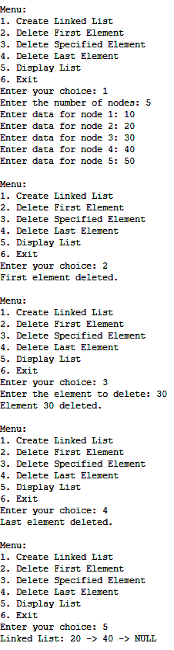

**1823. Find the winner of the circular game**

There are n friends that are playing a game. The friends are sitting in a circle and are numbered from 1 to n in clockwise order. More formally, moving clockwise from the ith friend brings you to the (i+1)th friend for 1 <= i < n, and moving clockwise from the nth friend brings you to the 1st friend.

The rules of the game are as follows:

Start at the 1st friend.

Count the next k friends in the clockwise direction including the friend you started at. The counting wraps around the circle and may count some friends more than once.

The last friend you counted leaves the circle and loses the game.

If there is still more than one friend in the circle, go back to step 2 starting from the friend immediately clockwise of the friend who just lost and repeat.

Else, the last friend in the circle wins the game.

Given the number of friends, n, and an integer k, return the winner of the game.

class Solution {

public:

    int findTheWinner(int n, int k) {

        // Initialize vector of N friends, labeled from 1-N

        vector<int> circle;

        for (int i = 1; i <= n; i++) {

            circle.push_back(i);

        }

        // Maintain the index of the friend to start the count on

        int startIndex = 0;

        // Perform eliminations while there is more than 1 friend left

        while (circle.size() > 1) {

            // Calculate the index of the friend to be removed

            int removalIndex = (startIndex + k - 1) % circle.size();

            // Erase the friend at removalIndex

            circle.erase(circle.begin() + removalIndex);

            // Update startIndex for the next round

            startIndex = removalIndex;

        }

        return circle.front();

    }

};

Output:

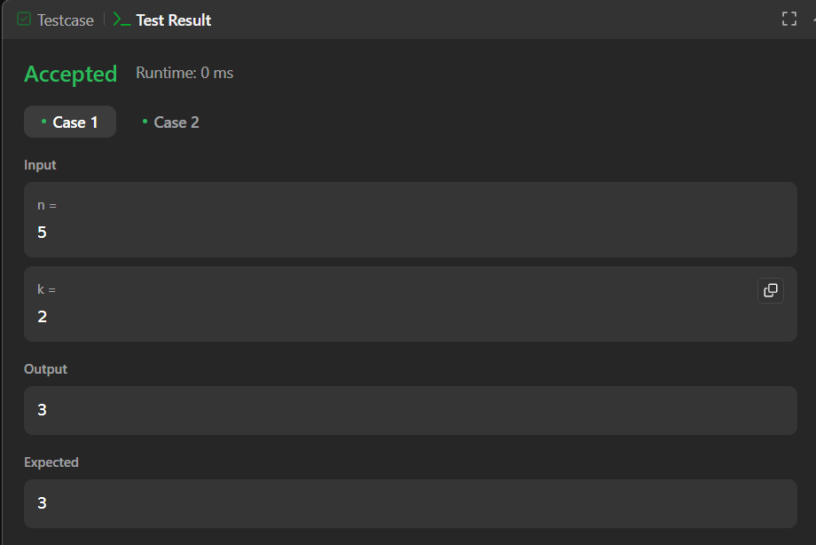

**Lab program 6:**

**a) WAP to Implement Single Link List with following operations: Sort the linked list, Reverse the linked list, Concatenation of two linked lists.**

#include <stdio.h>

#include <stdlib.h>

struct Node {

int data;

struct Node* next;

};

struct Node* createNode(int data) {

struct Node* newNode = (struct Node*)malloc(sizeof(struct Node));

newNode->data = data;

newNode->next = NULL;

return newNode;

}

void append(struct Node** head, int data) {

struct Node* newNode = createNode(data);

if (*head == NULL) {

*head = newNode;

return;

}

struct Node* temp = *head;

while (temp->next != NULL) {

temp = temp->next;

}

temp->next = newNode;

}

void display(struct Node* head) {

while (head != NULL) {

printf("%d -> ", head->data);

head = head->next;

}

printf("NULL\n");

}

void sortList(struct Node** head) {

if (*head == NULL || (*head)->next == NULL) {

return;

}

struct Node *i, *j;

int temp;

for (i = *head; i != NULL; i = i->next) {

for (j = i->next; j != NULL; j = j->next) {

if (i->data > j->data) {

temp = i->data;

i->data = j->data;

j->data = temp; }}}}

void reverseList(struct Node** head) {

struct Node *prev = NULL, *current = *head, *next = NULL;

while (current != NULL) {

next = current->next;

current->next = prev;

prev = current;

current = next;

}

*head = prev;

}

void concatenateLists(struct Node** head1, struct Node** head2) {

if (*head1 == NULL) {

*head1 = *head2;

return;

}

struct Node* temp = *head1;

while (temp->next != NULL) {

temp = temp->next;

}

temp->next = *head2;

}

int main() {

struct Node* list1 = NULL;

struct Node* list2 = NULL;

int choice, data;

do {

printf("\nMenu:\n");

printf("1. Append to List 1\n");

printf("2. Display List 1\n");

printf("3. Sort List 1\n");

printf("4. Reverse List 1\n");

printf("5. Append to List 2\n");

printf("6. Display List 2\n");

printf("7. Concatenate List 2 to List 1\n");

printf("8. Exit\n");

printf("Enter your choice: ");

scanf("%d", &choice);

switch (choice) {

case 1:

printf("Enter a number to append to List 1: ");

scanf("%d", &data);

append(&list1, data);

break;

case 2:

printf("List 1: ");

display(list1);

break;

case 3:

sortList(&list1);

printf("Sorted List 1: ");

display(list1);

break;

case 4:

reverseList(&list1);

printf("Reversed List 1: ");

display(list1);

break;

case 5:

printf("Enter a number to append to List 2: ");

scanf("%d", &data);

append(&list2, data);

break;

case 6:

printf("List 2: ");

display(list2);

break;

case 7:

concatenateLists(&list1, &list2);

printf("Concatenated List 1: ");

display(list1);

break;

case 8:

printf("Exiting program.\n");

break;

default:

printf("Invalid choice. Please try again.\n");

}

} while (choice != 8);

return 0;

}

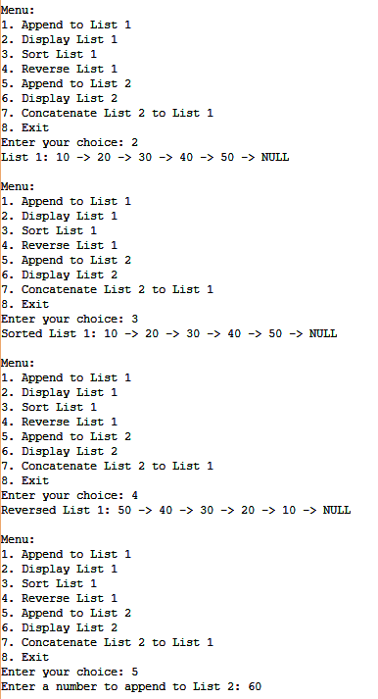

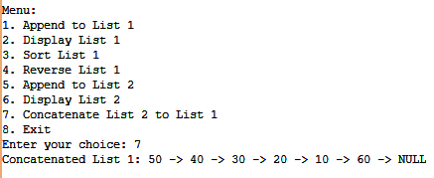

**b) WAP to Implement Single Link List to simulate Stack & Queue Operations.**

#include <stdio.h>

#include <stdlib.h>

struct Node {

int data;

struct Node* next;

};

struct Node* createNode(int data) {

struct Node* newNode = (struct Node*)malloc(sizeof(struct Node));

if (!newNode) {

printf("Memory allocation error\n");

exit(1);

}

newNode->data = data;

newNode->next = NULL;

return newNode;

}

void push(struct Node** top, int data) {

struct Node* newNode = createNode(data);

newNode->next = *top;

*top = newNode;

printf("Pushed %d to stack\n", data);

}

int pop(struct Node** top) {

if (*top == NULL) {

printf("Stack underflow\n");

return -1;

}

struct Node* temp = *top;

int popped = temp->data;

*top = (*top)->next;

free(temp);

return popped;

}

void enqueue(struct Node** front, struct Node** rear, int data) {

struct Node* newNode = createNode(data);

if (*rear == NULL) {

*front = *rear = newNode;

printf("Enqueued %d to queue\n", data);

return;

}

(*rear)->next = newNode;

*rear = newNode;

printf("Enqueued %d to queue\n", data);

}

int dequeue(struct Node** front, struct Node** rear) {

if (*front == NULL) {

printf("Queue underflow\n");

return -1;

}

struct Node* temp = *front;

int dequeued = temp->data;

*front = (*front)->next;

if (*front == NULL)

*rear = NULL;

free(temp);

return dequeued;

}

void display(struct Node* node) {

if (node == NULL) {

printf("List is empty\n");

return;

}

while (node != NULL) {

printf("%d -> ", node->data);

node = node->next;

}

printf("NULL\n");

}

int main() {

struct Node* stackTop = NULL;

struct Node* queueFront = NULL;

struct Node* queueRear = NULL;

int choice, value;

do {

printf("\nMenu:\n");

printf("1. Push to Stack\n");

printf("2. Pop from Stack\n");

printf("3. Display Stack\n");

printf("4. Enqueue to Queue\n");

printf("5. Dequeue from Queue\n");

printf("6. Display Queue\n");

printf("0. Exit\n");

printf("Enter your choice: ");

scanf("%d", &choice);

switch (choice) {

case 1:

printf("Enter value to push: ");

scanf("%d", &value);

push(&stackTop, value);

break;

case 2:

value = pop(&stackTop);

if (value != -1)

printf("Popped %d from stack\n", value);

break;

case 3:

printf("Stack contents: ");

display(stackTop);

break;

case 4:

printf("Enter value to enqueue: ");

scanf("%d", &value);

enqueue(&queueFront, &queueRear, value);

break;

case 5:

value = dequeue(&queueFront, &queueRear);

if (value != -1)

printf("Dequeued %d from queue\n", value);

break;

case 6:

printf("Queue contents: ");

display(queueFront);

break;

case 0:

printf("Exiting program...\n");

break;

default:

printf("Invalid choice! Please try again.\n");

}

} while (choice != 0);

return 0;

}

Stack:

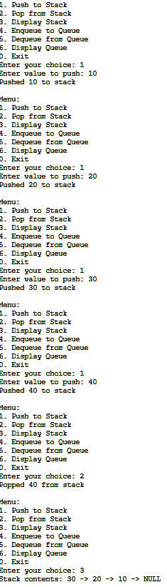

**Queue:**

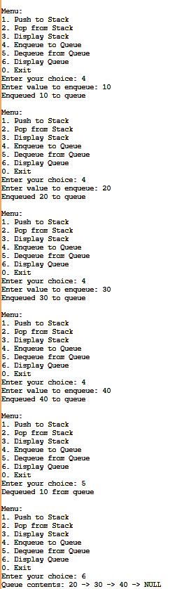

**Lab program 7:**

**WAP to Implement doubly link list with primitive operations**

**a) Create a doubly linked list.**

**b) Insert a new node to the left of the node.**

**c) Delete the node based on a specific value**

**d) Display the contents of the list**

#include <stdio.h>

#include <stdlib.h>

typedef struct Node {

int data;

struct Node* prev;

struct Node* next;

} Node;

Node* createNode(int data) {

Node* newNode = (Node*)malloc(sizeof(Node));

newNode->data = data;

newNode->prev = NULL;

newNode->next = NULL;

return newNode;

}

void append(Node** head, int data) {

Node* newNode = createNode(data);

if (*head == NULL) {

*head = newNode;

return;

}

Node* temp = *head;

while (temp->next) {

temp = temp->next;

}

temp->next = newNode;

newNode->prev = temp;

}

void insertLeft(Node** head, int target, int data) {

Node* newNode = createNode(data);

Node* current = *head;

while (current && current->data != target) {

current = current->next;

}

if (!current) {

printf("Node with value %d not found.\n", target);

free(newNode);

return;

}

newNode->next = current;

newNode->prev = current->prev;

if (current->prev) {

current->prev->next = newNode;

} else {

*head = newNode;

}

current->prev = newNode;

}

void deleteNode(Node** head, int value) {

Node* current = *head;

while (current && current->data != value) {

current = current->next;

}

if (!current) {

printf("Node with value %d not found.\n", value);

return;

}

if (current->prev) {

current->prev->next = current->next;

} else {

*head = current->next;

}

if (current->next) {

current->next->prev = current->prev;

}

free(current);

printf("Node with value %d deleted.\n", value);

}

void displayList(Node* head) {

Node* current = head;

if (!head) {

printf("The list is empty.\n");

return;

}

printf("List contents: ");

while (current) {

printf("%d ", current->data);

current = current->next;

}

printf("\n");

}

int main() {

Node* head = NULL;

int choice, data, target;

while (1) {

printf("\nDoubly Linked List Operations:\n");

printf("1. Create/Add a Node\n");

printf("2. Insert a Node to the Left of a Specific Node\n");

printf("3. Delete a Node by Value\n");

printf("4. Display the List\n");

printf("5. Exit\n");

printf("Enter your choice: ");

scanf("%d", &choice);

switch (choice) {

case 1:

printf("Enter the value to add: ");

scanf("%d", &data);

append(&head, data);

break;

case 2:

printf("Enter the value to insert: ");

scanf("%d", &data);

printf("Enter the target value to insert to the left of: ");

scanf("%d", &target);

insertLeft(&head, target, data);

break;

case 3:

printf("Enter the value to delete: ");

scanf("%d", &data);

deleteNode(&head, data);

break;

case 4:

displayList(head);

break;

case 5:

printf("Exiting...\n");

return 0;

default:

printf("Invalid choice! Please try again.\n");

}

}

}

Output:

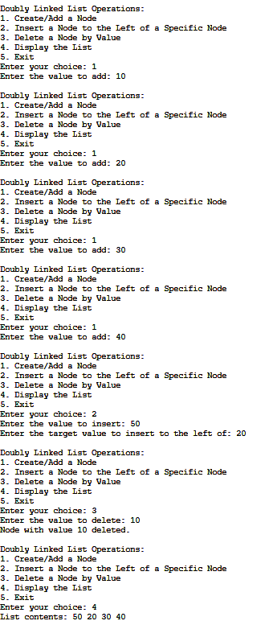

**Lab program 8:**

**Write a program**

**a) To construct a binary Search tree.**

**b) To traverse the tree using all the methods i.e., in-order,**

**preorder and post order**

**c) To display the elements in the tree.**

#include <stdio.h>

#include <stdlib.h>

typedef struct Node {

int data;

struct Node *left, *right;

} Node;

Node* createNode(int value) {

Node* newNode = (Node*)malloc(sizeof(Node));

newNode->data = value;

newNode->left = newNode->right = NULL;

return newNode;

}

Node* insert(Node* root, int value) {

if (root == NULL) {

return createNode(value);

}

if (value < root->data) {

root->left = insert(root->left, value);

} else if (value > root->data) {

root->right = insert(root->right, value);

}

return root;

}

void inorderTraversal(Node* root) {

if (root != NULL) {

inorderTraversal(root->left);

printf("%d ", root->data);

inorderTraversal(root->right);

}

}

void preorderTraversal(Node* root) {

if (root != NULL) {

printf("%d ", root->data);

preorderTraversal(root->left);

preorderTraversal(root->right);

}

}

void postorderTraversal(Node* root) {

if (root != NULL) {

postorderTraversal(root->left);

postorderTraversal(root->right);

printf("%d ", root->data);

}

}

int main() {

Node* root = NULL;

int choice, value;

do {

printf("\nBinary Search Tree Menu\n");

printf("1. Insert an element\n");

printf("2. Display In-order traversal\n");

printf("3. Display Pre-order traversal\n");

printf("4. Display Post-order traversal\n");

printf("5. Exit\n");

printf("Enter your choice: ");

scanf("%d", &choice);

switch (choice) {

case 1:

printf("Enter the value to insert: ");

scanf("%d", &value);

root = insert(root, value);

printf("Value inserted successfully.\n");

break;

case 2:

printf("In-order Traversal: ");

inorderTraversal(root);

printf("\n");

break;

case 3:

printf("Pre-order Traversal: ");

preorderTraversal(root);

printf("\n");

break;

case 4:

printf("Post-order Traversal: ");

postorderTraversal(root);

printf("\n");

break;

case 5:

printf("Exiting...\n");

break;

default:

printf("Invalid choice! Please try again.\n");

}

} while (choice != 5);

return 0;

}

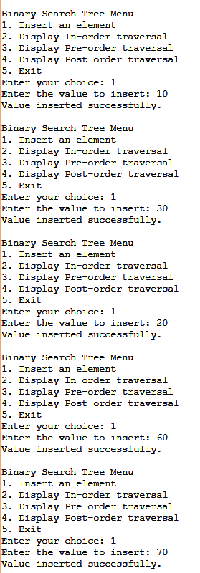

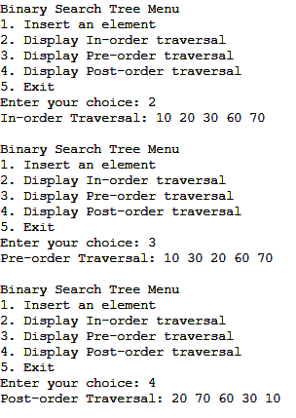

**Lab program 9:**

**A) Write a program to traverse a graph using BFS method.**

#include <stdio.h>

#include <stdlib.h>

int adj[MAX][MAX];

int visited[MAX];

int queue[MAX];

int front = -1, rear = -1;

void enqueue(int vertex) {

if (rear == MAX - 1) {

printf("Queue overflow\n");

return;

}

if (front == -1)

front = 0;

queue[++rear] = vertex;

}

int dequeue() {

if (front == -1 || front > rear) {

printf("Queue underflow\n");

return -1;

}

return queue[front++];

}

int isQueueEmpty() {

return (front == -1 || front > rear);

}

void bfs(int startVertex, int n) {

enqueue(startVertex);

visited[startVertex] = 1;

printf("BFS Traversal starting from vertex %d:\n", startVertex);

while (!isQueueEmpty()) {

int currentVertex = dequeue();

printf("%d ", currentVertex);

for (int i = 0; i < n; i++) {

if (adj[currentVertex][i] == 1 && !visited[i]) {

enqueue(i);

visited[i] = 1;

}

}

}

printf("\n");

}

int main() {

int n, edges, v1, v2, startVertex;

printf("Enter the number of vertices: ");

scanf("%d", &n);

printf("Enter the number of edges: ");

scanf("%d", &edges);

for (int i = 0; i < n; i++) {

for (int j = 0; j < n; j++) {

adj[i][j] = 0;

}

visited[i] = 0;

}

printf("Enter the edges (vertex1 vertex2):\n");

for (int i = 0; i < edges; i++) {

scanf("%d %d", &v1, &v2);

adj[v1][v2] = 1;

adj[v2][v1] = 1; // For undirected graph

}

printf("Enter the starting vertex for BFS: ");

scanf("%d", &startVertex);

// Perform BFS

bfs(startVertex, n);

return 0;

}

Output:

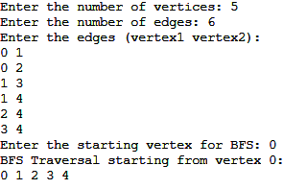

**B)** **Write a program to check whether given graph is connected or not using DFS method.**

#include <stdio.h>

#include <stdlib.h>

#define MAX 100

int adj[MAX][MAX];

int visited[MAX];

void dfs(int vertex, int n) {

visited[vertex] = 1;

printf("%d ", vertex);

for (int i = 0; i < n; i++) {

if (adj[vertex][i] == 1 && !visited[i]) {

dfs(i, n);

}

}

}

int isConnected(int n) {

for (int i = 0; i < n; i++) {

visited[i] = 0;

}

dfs(0, n);

for (int i = 0; i < n; i++) {

if (visited[i] == 0) {

return 0;

}

}

return 1;

}

int main() {

int n, edges, v1, v2;

printf("Enter the number of vertices: ");

scanf("%d", &n);

printf("Enter the number of edges: ");

scanf("%d", &edges);

for (int i = 0; i < n; i++) {

for (int j = 0; j < n; j++) {

adj[i][j] = 0; // No edge by default

}

}

printf("Enter the edges (vertex1 vertex2):\n");

for (int i = 0; i < edges; i++) {

scanf("%d %d", &v1, &v2);

adj[v1][v2] = 1;

adj[v2][v1] = 1;

}

if (isConnected(n)) {

printf("The graph is connected.\n");

} else {

printf("The graph is not connected.\n");

}

return 0;

}

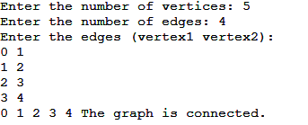

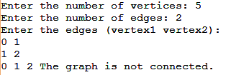

**Lab program 10:**

**Given a File of N employee records with a set K of Keys(4-digit) which uniquely determine the records in file F.**

**Assume that file F is maintained in memory by a Hash Table (HT) of m memory locations with L as the set of memory addresses (2-digit) of locations in HT.**

**Let the keys in K and addresses in L are integers.**

**Design and develop a Program in C that uses Hash function H: K -> L as H(K)=K mod m (remainder method), and implement hashing technique to map a given key K to the address space L.**

**Resolve the collision (if any) using linear probing.**

**Code:**

#include <stdio.h>

#include <stdlib.h>

#define MAX_KEYS 100

void initializeHashTable(int hashTable[], int m) {

for (int i = 0; i < m; i++) {

hashTable[i] = -1;

}

}

int hashFunction(int K, int m) {

return K % m;

}

void insertIntoHashTable(int hashTable[], int m, int key) {

int index = hashFunction(key, m);

while (hashTable[index] != -1) {

index = (index + 1) % m;

}

hashTable[index] = key;

printf("Key %d inserted at index %d\n", key, index);

}

void displayHashTable(int hashTable[], int m) {

printf("\nHash Table:\n");

for (int i = 0; i < m; i++) {

if (hashTable[i] != -1) {

printf("Index %d -> Key %d\n", i, hashTable[i]);

} else {

printf("Index %d -> Empty\n", i);

}

}

}

int main() {

int m, n;

int keys[MAX_KEYS]; // Array to store the keys (employee records)

printf("Enter the number of memory locations in hash table (m): ");

scanf("%d", &m);

printf("Enter the number of keys (n): ");

scanf("%d", &n);

printf("Enter the keys (4-digit integers):\n");

for (int i = 0; i < n; i++) {

scanf("%d", &keys[i]);

}

int hashTable[m];

initializeHashTable(hashTable, m);

for (int i = 0; i < n; i++) {

insertIntoHashTable(hashTable, m, keys[i]);

}

displayHashTable(hashTable, m);

return 0;

}

